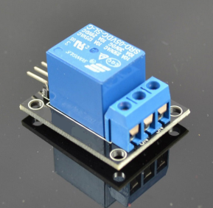
Step 1: connect Relay module, HC06 bluetooth sensor to arduino as per following graph.
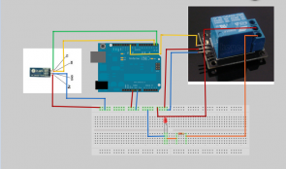
Step 2: Download Amarino app into your android cell phone or other android device. Open the app and search the bluetooth device “HC06″ and pair it with android device. use the default passcode “0000” or “1234”.
Step 3: Download sketch code and load it into arduino.
Step 4: Type a character “1” in android app, the LED in the circuit will turn on. Type a character “0” in android app, the LED in the circuit will turn off.

